Key?

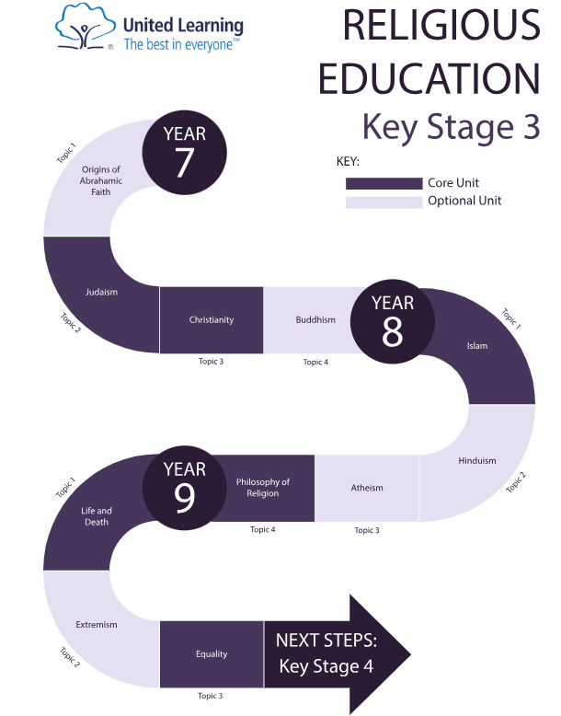

YEAR 9

YAR 7