Equality and Inclusion Statement
Date: April 2024

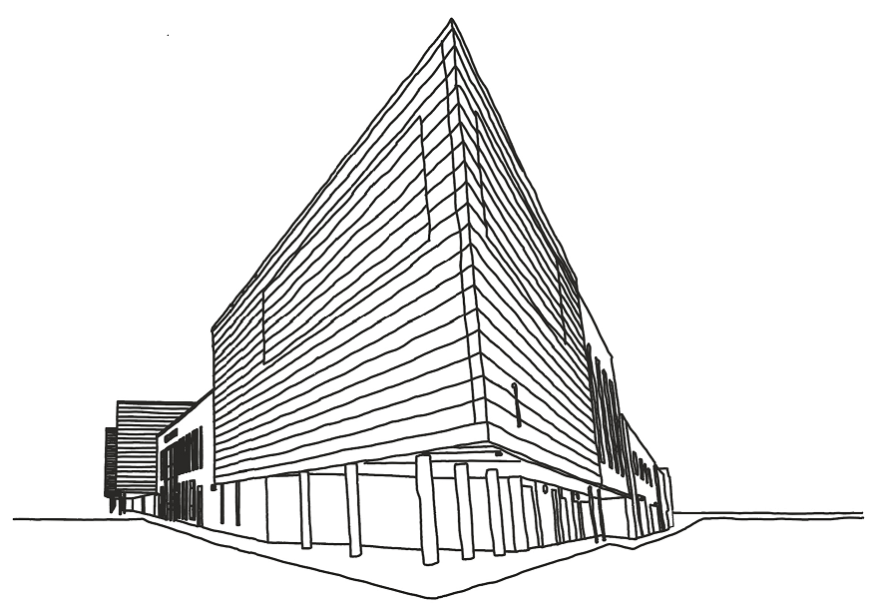

1. Introduction

Sheffield Springs Academy is committed to promoting equality, diversity, and inclusivity within its school community. This policy outlines our vision and commitment to creating a supportive and inclusive environment for all students, staff, and stakeholders.

This policy aligns with the values of United Learning, emphasising respect, diversity, and equality in education.

In accordance with the Equality Act 2010, it is unlawful to discriminate directly or indirectly in recruitment or employment because of age, disability, sex, gender reassignment, pregnancy, maternity, race (which includes colour, nationality and ethnic or national origins), sexual orientation, religion or belief, or because someone is married or in a civil partnership. These are known as "protected characteristics”.

2. Vision Statement

Sheffield Springs Academy envisions a school community where all individuals, regardless of race, ethnicity, gender, religion, disability, sexual orientation, or socio-economic background, feel valued, respected, and empowered to achieve their full potential.

We strive to foster a culture of equality, where diversity is celebrated, and differences are embraced as strengths.

3. Core Principles

Upholding the principles of equality, diversity, and inclusion in all aspects of school life, including teaching and learning, recruitment and retention, and student support services.

Promoting fairness and equity by challenging discrimination, prejudice, and stereotypes.

Ensuring that all members of the school community have equal access to opportunities, resources, and support mechanisms.

4. Implementation Guidelines

Curriculum and Teaching: Incorporating diverse perspectives, histories, and cultures into the curriculum to promote understanding and empathy among students. Providing training and resources for teachers to deliver inclusive and culturally responsive instruction.

Recruitment and Staff Development: Implementing fair and transparent recruitment processes to attract a diverse workforce. Providing ongoing training and professional development opportunities for staff to enhance their understanding of equality issues and inclusive practices. Sheffield Springs Academy will avoid unlawful discrimination in all aspects of employment including recruitment, promotion, opportunities for training, pay and benefits, discipline and selection for redundancy. Person and job specifications will be limited to those requirements that are necessary for the effective performance of the job. Candidates for employment or promotion will be assessed objectively against the requirements for the job, taking account of any reasonable adjustments that may be required for candidates with a disability. Disability will not form the basis of employment decisions except where necessary and will make reasonable adjustments to overcome barriers caused by disability. Sheffield Springs Academy will adopt United learning Flexible working policy when considering requested workplace adjustments.

Student Support and Welfare: Establishing support systems and mechanisms to address the needs of students from diverse backgrounds, including those with disabilities, English language learners, and students from disadvantaged socio-economic backgrounds. Implementing anti-bullying policy to ensure a safe and respectful learning environment for all students.

Community Engagement: Collaborating with parents, guardians, and community organisations to promote diversity and inclusion within the school and wider community. Providing opportunities for stakeholders to participate in decision-making processes and initiatives aimed at promoting equality and social justice.

5. Monitoring and Evaluation

Regularly monitoring and evaluating the effectiveness of this policy in promoting equality and inclusion within the school community.

Collecting and analysing data on student achievement, staff demographics, and incidents of discrimination or harassment to identify areas for improvement and inform future actions.

The Senior leadership team will be responsible for ensuring staff awareness and promotion of these guidelines.

The senior leadership team will review which staff have and have not been selected for training events.

6. Review and Amendments

Reviewing this policy annually to ensure alignment with legislative requirements, best practices, and United Learning Schools' values.
Welcoming feedback from stakeholders and considering proposed amendments to further strengthen our commitment to equality and inclusion.

7. Grievances
If you consider that you may have been unlawfully discriminated against, you may use Sheffield Springs Academy’s grievance procedure to make a complaint. Alternatively, if you feel that you have been subject to harassment and bullying, you should refer to Sheffield Springs Academy’s Anti-Bullying policy and United Learning Grevience Policy.
Sheffield Springs Academy will take any complaint seriously and will seek to resolve any grievance that it upholds. You will not be penalised for raising a grievance, even if your grievance is not upheld, unless your complaint is both untrue and made in bad faith
8. Approval and Implementation

This guidence is approved by the Sheffield Springs Academy Board of Governors and will be communicated to all staff, students, and stakeholders via the website.

Appendix 1 - Definitions of Discrimination
Direct discrimination is where a person is treated less favourably than another because of a protected characteristic. An example of direct discrimination would be refusing to employ a woman because she is pregnant.
In limited circumstances, employers can directly discriminate against an individual for a reason related to any of the protected characteristics where there is an occupational requirement. The occupational requirement must be crucial to the post and a proportionate means of achieving a legitimate aim.
Indirect discrimination is where a provision, criterion or practice is applied that is discriminatory in relation to individuals who have a relevant protected characteristic (although it does not explicitly include pregnancy and maternity, which is covered by indirect sex discrimination) such that it would be to the detriment of people who share that protected characteristic compared with people who do not, and it cannot be shown to be a proportionate means of achieving a legitimate aim.
Harassment is where there is unwanted conduct, related to one of the protected characteristics (other than marriage and civil partnership, and pregnancy and maternity) that has the purpose or effect of violating a person’s dignity; or creating an intimidating, hostile, degrading, humiliating or offensive environment. It does not matter whether or not this effect was intended by the person responsible for the conduct.
Associative discrimination is where an individual is directly discriminated against or harassed for association with another individual who has a protected characteristic (although it does not cover harassment because of marriage and civil partnership, and (according to guidance from the Government and Acas) pregnancy and maternity).
Perceptive discrimination is where an individual is directly discriminated against or harassed based on a perception that he/she has a particular protected characteristic when he/she does not, in fact, have that protected characteristic (other than marriage and civil partnership, and pregnancy and maternity).
Third-party harassment occurs where an employee is harassed and the harassment is related to a protected characteristic (other than marriage and civil partnership, and pregnancy and maternity), by third parties such as clients or customers. For an employer to be liable: •
- The harassment must have occurred on at least two previous occasions (although not necessarily by the same harasser or suffering the same type of harassment); •
- It must be aware that the previous harassment has taken place; and •
- It must have failed to take reasonable steps to prevent harassment from happening again.
Victimisation occurs where an employee is subjected to a detriment, such as being denied a training opportunity or a promotion because he/she made or supported a complaint or raised a grievance under the Equality Act 2010, or because he/she is suspected of doing so. However, an employee is not protected from victimisation if he/she acted maliciously or made or supported an untrue complaint. There is no longer a need for a complainant to compare his/her treatment with someone who has not made or supported a complaint under the Equality Act 2010. For example, if a blind employee raises a grievance that the employer is not complying with its duty to make reasonable adjustments, and is then systematically excluded from all meetings, such behaviour could amount to victimisation
Failure to make reasonable adjustments is where a physical feature or a provision, criterion or practice puts a disabled person at a substantial disadvantage compared with someone who does not have that protected characteristic and the employer has failed to make reasonable adjustments to enable the disabled person to overcome the disadvantage.

