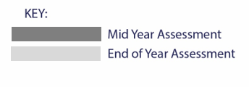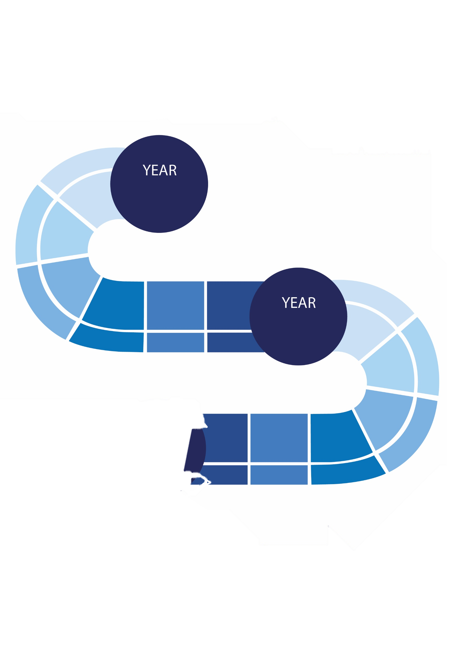



Unseen Poetry

Revisiting: MCB/ACC

**Language:**

Mid-year Assessment: Paper 1

End of year assessment: Paper 1 + Paper 2

**Literature:**

Mid-year Assessment: Paper 2

End of year assessment: Paper 1 + Paper 2

**Y11 Assessments**

**Literature:**

Mid-year Assessment: Paper 1

End of year assessment: Paper 1 + Power and Conflict

**Language:**

Mid-year Assessment: Paper 1

End of year assessment: Paper 1 + Paper 2

**Y10 Assessments**

Key Stage 4

ENGLISH

**2023-2024**

Macbeth

Revisiting: P&C and Unseen

An Inspector Calls

Revision

Allegorical; a ghost story

Shakespeare: Tragedy

Revision

Language: AQA Paper 1 and Paper 2

EXAMS

Exam Revision- Bespoke

Revision: Macbeth

ACC

P&C

Power and Conflict Anthology

A Christmas Carol

Power and Conflict Anthology

Language: AQA Paper 1 and Paper 2

10

NEXT STEPS:

Key Stage 5

11

Edit Key Stage

Play/Prose

Poetry

Drama/Play

Edit Genre

Edit Genre

Edit Genre

EXAMS

Edit Genre

Edit Text

Edit Text

Edit Text

Edit Text

Poetry

Poetry

Poetry