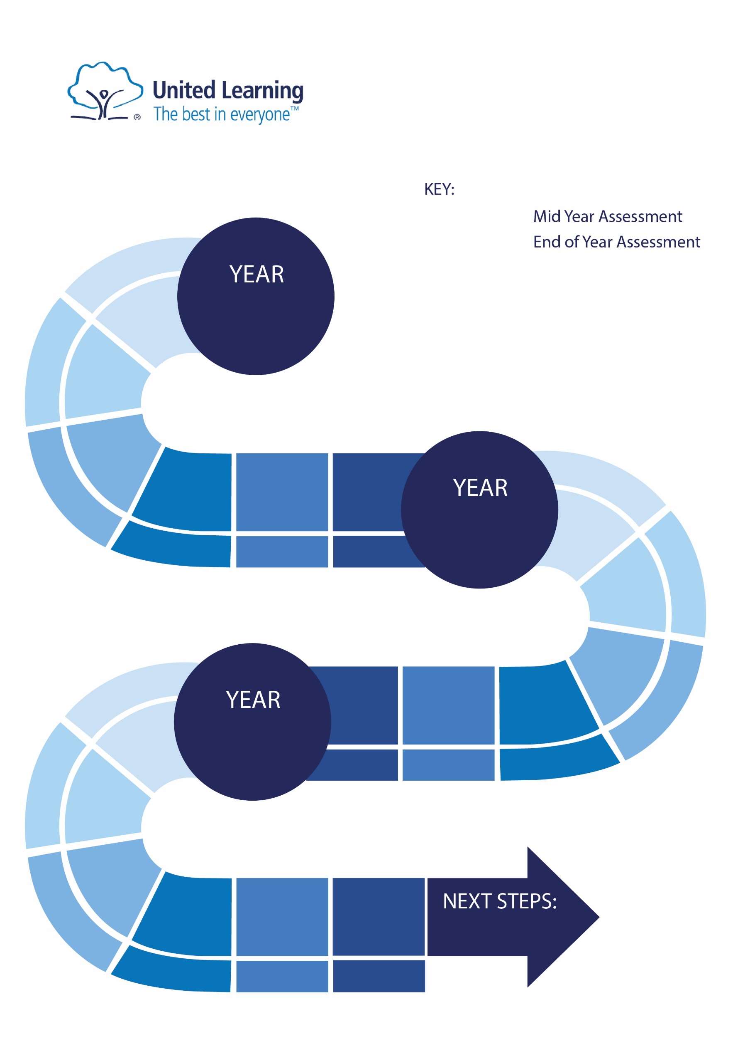

Creative Writing

Allegorical Writing

Gothic   
Writing

**Texts in red font are assessed formally in UL assessments.**

The Girl of Ink and Stars

Relationships & Identity Anthology

Unseen Poetry

Shakespeare: Tragedy Tragedy

King Lear

Relationships & identity Anthology

Creative Writing

Animal Farm

Creative Writing

=

Dracula

Key Stage 3

**2023-2024**

ENGLISH

Non-Fiction Project

Romeo and Juliet

Adventure Writing

Novella

Short Stories

Detective Fiction

Short Stories: The Adventures of Sherlock Holmes

Blood Brothers

Short Story

Poetry

Dystopian

Short Stories

Social

Justice Poetry

Shakespeare:

Comedy

Poetry

A Midsummer Night’s Dream

Drama/Play

Shakespeare: Tragedy

Gothic

Deception & Secrecy, Power

Relationships, Love, Identity

Deception & Secrecy, Coming-of-Age, Power

Relationships, Love, Gender

Relationships, Love, Gender, Identity

Conflict, Deception, Coming-of-Age, Power

Conflict

Anthology

The Wolves of Willoughby Chase

Non-Fiction

Adventure Bildungsroman

Adventure Bildungsroman

Key Stage 4

9

8

7