Behaviour Policy & Code of Conduct for Pupils
Updated September 2023 signed off by the Local Governing Body

Those members of staff who are authorised by the Headteacher as being in control or in charge of pupils are:

- Any teacher who works at the academy
- Any other person whom the Headteacher has authorised to have control or charge of pupils.

This includes:
- Support staff whose job normally includes supervising pupils such as teaching assistants, learning support assistants, learning mentors and lunchtime supervisors
- Teach First, School Direct or PGCE students under the guidance of their mentors
- People to whom the Headteacher has granted temporary authorisation to have control or charge of pupils such as paid members of staff whose job does not normally involve supervising pupils (for example catering or premises-related staff) and unpaid volunteers (for example parents accompanying pupils on school-organised visits)
- Teachers and other senior, qualified professionals from within the United Learning group who are present in the academy or who are in attendance at events at which Sheffield Springs Academy pupils are present

It does not include:

- Prefects or Pupil Ambassadors

The policy applies where pupils are on the academy premises or elsewhere in the lawful control or charge of the staff member (for example on a school visit).

The policy also applies in circumstances where pupils are not on the premises of the academy or when they are not under the control of an authorised person such as on a bus to or from the academy or an academy event (such as a sporting fixture), walking to or from the academy or an academy event in the academy’s community and identifiable as a pupil at the academy.

The academy’s expectation is that when ‘off premises’ all pupils should conduct themselves in an appropriate, responsible and considerate manner. Anti-social behaviour in the community will not be tolerated.

The policy also applies where a pupil’s behaviour outside the academy has an impact or is likely to have an impact on the orderliness of the academy’s learning environment (either directly or indirectly). Examples of this are:
- Involvement in community based anti-social behaviour which may cause offence / has caused offence to others and which may / has led to conflict
- Posting of electronic messages (e.g., via Facebook, Twitter or by Text or Email) which may cause offence / has caused offence to others and which may / has led to conflict
- Bringing the academy into disrepute or acting in a manner which is likely to bring the academy into disrepute by acting in a disorderly or anti-social manner and being identifiable as a member of the academy community either through the wearing of the academy uniform, through the wearing or display of the academy logo or through being known by ‘common association’ with the academy within the community.

The sanctions for behaviours where pupils are not on the academy premises will be proportionate with those outlined in this policy for misbehaviour whilst in the academy.

Expectations

We have very high expectations of students because we believe that all students are capable of meeting our high standards and we ensure that students are well supported in meeting these standards. We use the phrase ‘no excuses’ as we believe that there are no excuses for poor behaviour and disruption to learning. There may be reasons, but not excuses. We aim to create a positive environment based on our core values, Excellence, Pride and Ambition. We believe that every student deserves a safe and secure disruption-free academy, every minute of every lesson and we are insistent on this because we know that the life chances of our students depend on it.

Sheffield Springs Academy has high expectations of all pupils in that they will act in such a way as to actively promote United Learnings ethos of ‘The Best in Everyone’ by:

- Showing respect for other people and the school both inside the academy and in the wider community
- Using appropriate language and behaving in a sensible manner
- Acting responsibly at all times
- Following instructions, first time, every time
- Arriving on time, fully prepared to learn
- Never bullying others
- Never acting in a manner which could bring the academy into disrepute
- Taking pride in their appearance by wearing the full academy uniform (see planner for further guidance)

All incidents of unacceptable behaviour will be dealt with in a fair and appropriate way. It is important that the academy recognises and rewards positive behaviour and achievement. The support of all parents and carers is essential to the academy’s successful implementation of this policy.

We expect that the above is fully supported by parents / carers and that by choosing to send their child to the academy, each parent is unreservedly agreeing to support the academy’s implementation of this behaviour policy to ensure that their child’s behaviour is appropriate and commensurate with a calm, productive learning environment in which all pupils can feel safe and valued.

In applying this policy, Sheffield Springs Academy will take into account its duties under the Equality Act 2010 regarding relevant characteristics protected by that act. It will also take into account the needs of pupils with special educational needs. The school will also have regard to its safeguarding policy where appropriate.

Policy Implementation
Our behaviour policy begins from the principle that learning in the classroom is where we want every student to be, but we must have disruption-free classrooms where teachers are able to teach to the best of their ability and students are able to learn. It places a great deal of responsibility on the student to meet expectations and follow instructions: we believe that every student has the ability to learn effectively and behave well. We do not accept any excuses for poor behaviour: we are ambitious for our students and set the highest standards for them and support them in meeting our expectations. We firmly believe that everyone has a right to feel secure and to be treated with respect, particularly the vulnerable, and harassment and bullying in any form are not tolerated, including online, or outside of school. Furthermore, that the School is strongly committed to promoting equal opportunities for all and takes its duties under the Equality Act 2010 seriously and makes appropriate reasonable adjustments for pupils with SEND.

The responsibility for implementing, adhering to and supporting the policy is as follows:

All staff to implement the Academy policy consistently and fairly throughout the school by setting the standards required to promote positive behaviour.

The senior leadership team of the Academy to ensure all staff adhere to the behaviour policy and implement effective systems for keeping records of all reported incidents, reporting to governors and parents when required, and to be a highly visible presence around the Academy engaging with all stakeholders in setting and maintaining a behaviour culture.

Students are responsible for: adhering to the values of Excellence, Pride and Ambition, and for meeting the behaviour expectations outlined in this policy. This includes, but is not limited to, conduct in lessons, meeting the ‘Springs 6’ expectations and adhering to the community 5 expectations when outside of lessons.

Parents are responsible for: The role of parents is crucial in helping schools develop and maintain good behaviour. To support the school, parents are encouraged to get to know the school’s behaviour policy and where possible, take part in the life of the school and its culture.

At Sheffield Springs Academy we value our close relationships with parents and encourage parents to work in partnership with the school to assist in maintaining high standards of behaviour both inside and outside of school. In particular, that the school expects parents to support the school’s values in matters such as attendance and punctuality, behaviour and conduct, uniform, standards of academic work, extra-curricular activities and homework.

In the event of any behaviour issue, Sheffield Springs Academy will liaise closely with parents and where practical and, if relevant, other local or national support agencies.

The Academy is committed to the continuous reinforcement of the behaviour policy in all that we do to ensure that standards of behaviour are maintained and improved over time. In particular, the policy is reinforced in the following ways:
- Staff Training: all staff are trained in implementing the behaviour policy in a consistent and fair manner. There are frequent refresher sessions to ensure that the message remains the same and that standards are maintained.
- Standardised displays: all classrooms display consistent posters to ensure that students are constantly reminded of what is expected.
- Assemblies: these are used as an opportunity to constantly reinforce high expectations of behaviour to students and to react to any particular issues that may arise.
- Home-school agreement: This is signed by all students before they join the Academy and reinforces to students and parents key messages about standards of behaviour and items that are banned from the Academy.
- Student Planner: this outlines behaviour expectations and lists items that are banned from the Academy. It can also be used as a form of communication between parents and the Academy about any aspects of student behaviour.
- Academy website: this has a copy of the Behaviour Policy

Behaviour expectations
Our behaviour policy begins from the principle that learning in the classroom is where we want every student to be, but we must have disruption-free classrooms where teachers are able to teach to the best of their ability and students are able to learn. It places a great deal of responsibility on the student to meet expectations and follow instructions: we believe that every student has the ability to learn effectively and behave well. We do not accept any excuses for poor behaviour: we are ambitious for our students and set the highest standards for them and support them in meeting our expectations. The school rules and policies concerning behaviour and discipline apply at all times when a pupil is at the school, representing the school, travelling to and from the school, and associated with the school at any time. This includes conduct online, such as in any written or electronic communication concerning the school and United Learning.

Springs 6
Our expectations of student behaviour start with ‘Springs 6’. All students at Sheffield Springs Academy are expected to be ‘Lesson Ready’ at the beginning of every lesson as this helps to ensure that learning time is maximised.
The Springs 6 expectations are:

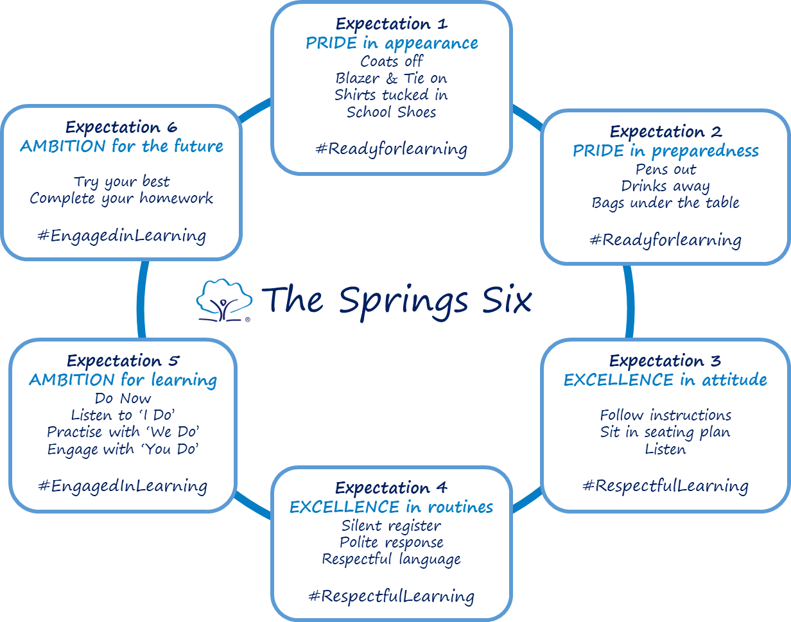

These expectations are displayed in each classroom as well as in student planners and are referred to and reinforced with students during assemblies, in student induction and re-induction.

During Lessons
Students must turn up to lessons on time and sit in silence completing the ‘do now’ task. This helps to make sure that the start of lessons is calm and that students are working from the beginning of the lesson.
Rewards

The Academy rewards good behaviour, as it believes that this will develop an ethos of kindness and cooperation in and around the Academy. This policy is designed to promote good behaviour and encourages students to support the school’s values of Excellence, Pride and Ambition.

The reward system aims to create a clear, simple, and recognisable structure that students and staff can use consistently, enabling students to feel more committed to school life and our values. Our reward system revolves around showing ‘good character’ around the Academy and working to the best of our abilities in lesson.

At the end of the lesson the teacher may award reward points on Arbor for those students who have shown the school’s values of Excellence, Pride and Ambition. Similarly, students can also receive reward points for showing these values around the Academy i.e., picking up litter - Respect
Students will automatically be awarded 6 achievement points per day for:
- Attending all 6 lessons
- Being on time for all 6 lessons
- Not gaining behaviour points

Pupils should be recognised for:
- Positive contributions to lessons
- Helping others
- Outstanding work
- Positive contribution to the Academy
- Outstanding homework
- Positive engagement
- Academic achievement
- Going the extra mile
- Service to the wider community
- Outstanding group work
- Independence in learning
- Showing examples our core values of Pride, Excellence and Ambition

Rewards in recognition of progress
- Achievement points
- SLT commendations
- Headteachers learner of the week award
- Golden ticket rewards for displaying Pride, Excellence and Ambition in lessons
- In it to win it – 100% attendance, 0 lates and 0 behaviour points
- Achievement assemblies after each Assessment Point (6 per year)
- Special Awards assemblies with parents invited
- Formal letter from Headteacher
- Headteacher lunches
- Achievement badges

Less frequent ‘long term success’ rewards
- Reward trips
- Tangible rewards e.g., vouchers
- Participation in special activities
- Milestone awards, Bronze, Silver, Gold and Platinum
- Pop up rewards events
End of term/year reward events

Sanctions
To uphold the highest standards of behaviour, Sheffield Springs Academy operates a Disruption Free Learning System. This is based on the following principles:

• every student has the right to learn in a disruption free academy

• teachers have the right to teach in a disruption free academy

• students are either in lessons learning or they are not

• students arrive to lessons fully equipped

• students will make excellent progress in every lesson, every day.

The Academy does not tolerate disruption to learning or defiance; these behaviours can compromise the learning of other students or compromise the safety of students and staff. Students therefore have a responsibility to ensure that they conduct themselves in a safe and compliant manner that allows themselves and other students to be both safe and able to learn. Students were consulted on what defines disruption to learning and defiance and they produced a list of behaviours that students will receive warnings for:

Sanctions given for the following | Immediate referral to the Student Support Unit - Removal | Immediate referral to the Student Support Unit – Reflection / High Tarrif behaviours
- Low-level disruption  - Calling out  - Off-task chatter  - Talking over a teacher (or after a countdown)  - Distracting others  - Bickering or unkindness  - Rudeness  - Physical contact  - Refusal to follow instructions  - Shouting  - Refusal to work  - Leaving seat without permission  - Eating in class (including chewing gum)  - Use or sound of mobile phone / headphones (items will be confiscated)  - Swinging on chair  - Turning around on seat  - Failing to sit up straight and pay attention  - Head on the desk or in your arms  - Not facing the speaker  - Not completing independent work in line with Academy expectations.  - Empathy to learning e.g.: daydreaming  Anything that slows down learning | - Lateness to lesson (After the late bell)  - Arguing with or undermining staff  - Play fighting during social time  - Throwing an object  - Receiving a second sanction in a lesson  Anything that slows down learning | - Truanting on or off-site  - Fighting  - Intimidating/obstructing/manhandling/ swearing at staff  - Violence/threats of violence/sexual harassment  - Highly disruptive behaviour  - Bullying including racist, homophobic or cyber-bullying incidents  - Lack of correct uniform - trainers, trousers, skirts (when offered option to correct)  - Refusing to remove unacceptable piercings  - Refusing to hand mobile phone in  - Damaging equipment or property  - Vandalism  - Defiance e.g., saying no  - Treating others in a disrespectful manner  - Being in possession of a prohibited item (such as energy drink) and refusing to submit it to a member of staff  Any other behaviours adjudged to be “high tariff” by the Principal / Deputy Principals (including the making of allegations against staff or other pupils which after investigation, are found to be of a malicious or vexatious nature)
Any continued high tariff behaviours causing disruption to the academy may lead to the student being issued a suspension.
Behaviours that are low level but when are displayed repeatedly or continue to be displayed after repeated warnings can seriously disrupt learning in class. Pupils who continue to disrupt learning will be removed from the classroom and escorted to the Student Support Unit. The following will happen:

- First warning – S1: The teacher will caution the student verbally and ensure the student is reminded of expectations that are clearly displayed in each classroom.
- Student Support Unit Removal room – S2: If a student disrupts learning a second time, the teacher will notify ‘On Call’ and the student will be picked up by a member of staff and taken to The Removal room found in the Student Support Unit. The student will then spend the remainder of that period and the next period in the removal room, reflecting on their behaviour and completing schoolwork on their laptop.
- Student Support Unit Reflection room – HT: If a student displays behaviour that are deemed to be a high tariff then they will be removed from learning in the classroom and complete at least a full working day in the Reflection room as well as an additional 50-minutes at the end of the academy day. A student will also be referred to the Reflection room if they have received two sanction 2s in the same day. Pupils will be expected to hand in their mobile phone onto the teacher’s desk, remove any non-school item of clothing and take a seat at a computer allocated by the member of staff in the room. Pupils are expected to follow their timetable and access lessons through MS Teams or Oak Academy.

All classroom teachers are expected to follow a 1,2 Sanction process to the address inappropriate behaviours in the classroom.

In the unlikely event that a detained pupil has been unable to have lunch served to them (e.g., there is still a queue when the Period 5 bell rings, food has run out) they should present themselves to the Principal’s PA (B5) and they will be provided with lunch. The academy does not wish for ANY pupil to go hungry.

The ‘On Call Support’ Provision

The “On-Call Support” provision is a facility which exists to support teachers in circumstances where they have implemented all possible behaviour for learning strategies and have exhausted the academy’s “Sanction 1 and Sanction 2” behaviour management processes.

“On-Call” should not be seen as a behaviour management tool or part of the teacher’s “normal” toolkit when dealing with behaviour in the classroom. “On-Call” should only be utilised when all other strategies have been unsuccessful.

Pupils are to wait to be collected by a member of the staff and not to leave the classroom.

Reasonable Adjustments

To support students with specific barriers to learning Sheffield Springs Academy will make any reasonable adjustment to helps these students succeed.

Green Student Support Group (GSSG) - SEND
Red Student Support Group (RSSG) – Disadvantaged
Amber Student Support Group (ASSG) – Risk of Permanent Exclusion
Blue Student Support Group (BSSG) – Safeguarding & Emotional Wellbeing

The academy recognises that significant events in young people's lives might impact on their ability to process information and interact in a rational manner with others for periods of time. This does not and should not mean that our expectations of them should be lowered, nor should our standards. However, it is important that we are both compassionate and supportive and we should consider the circumstances of our most vulnerable pupils prior to levying a sanction.

Student identified in the Green Student Support Group may have barriers to learning due to their Special educational needs and/or disabilities.

Student identified in the Red Student Support Group may have barriers to learning due to their disadvantaged circumstances and/or history of deprivation.

Student identified in the Amber Student Support Group are at significant risk of permeant exclusion and will receive intense support from the Pastoral Head of Year.

Students identified in the Blue Student Support Group may have barriers to learning due to their Safeguarding and emotional wellbeing circumstances, including.
- have recently lost a close relative.
- have a significant safeguarding issue that we are aware of.
- have lost their home or are at risk of homelessness.
- are experiencing or have recently experienced domestic violence
- are a Looked After Child / young carer
- are adjusting to the impact of the introduction of or changes to medication

The students identified will receive support to help change their emotions, routines, and the ability to meet academy expectations. Any reasonable adjustments made will be sensible, appropriate and proportionate to the needs of the child and those of the school. This information will be kept confidential.

‘Red line’ Behaviour
There are certain behaviours that will not be tolerated and ones for which a student is likely to receive a suspension from school:
- Smoking, vaping, drugs, or alcohol on our site
- Stealing from our academy or another pupil or intentionally damaging property of others, including our academy
- Abuse of the academy’s computer systems
- Sexual harassment, abuse, or assault
- Serious actual or threatened violence
- Knives, other offensive weapons, or items that have been modified to cause harm
- Racist or homophobic harassment
- Extremist behaviour - seeking to engage or recruit others to extremist ideologies
- Continually refusing to follow expectations, causing disruption to our academy
- False accusations against members of staff

Suspensions and permanent exclusions
Suspension is a very serious sanction and not taken lightly. The decision to suspend a student from the academy is made only by the Headteacher (or ‘Deputy Headteacher if the Headteacher is not available. The Deputy Headteacher is designated as ‘Acting’ in this instance). Parent/carer will be informed by telephone and by letter if their child is suspended as well as the social worker if a pupil has one allocated. Parents/carers are legally responsible for their child for the first 5 days of any suspension, and they must be at home during this period. Work will be set via MS teams or National Oak Academy. Parents/carers are expected to attend a reintegration meeting with a member of the behaviour or senior team and sometimes a governor on return from any exclusion. See Exclusion Policy for more detail.

Allegations against staff
Sheffield Springs Academy takes its responsibilities for safeguarding extremely seriously, and with this in mind we are clear that any allegation of improper behaviour or unprofessional conduct made against a member of staff will be treated with the utmost seriousness and will be managed in accordance with the procedures set out in the Safeguarding Policy.

Malicious accusations against staff
Sheffield Springs Academy reserves the right to take disciplinary action, including suspension and up to permanent exclusion, against pupils who are found to have deliberately invented or made malicious accusations, whether against other pupils, staff, or other individuals.

Child-on-child sexual violence and sexual harassment
In every aspect of Sheffield Springs Academy, sexual violence and sexual harassment are never acceptable and will not be tolerated. Students whose behaviour falls below our expectations both in language as well as action will be sanctioned. This can include suspension and up to permanent exclusion. This is because we strongly believe that all students and staff deserve to be in an environment which is free of the risk of sexual harassment and sexual violence.

Behaviour incidents online
When considering behaviour incidents online we are clear that the behaviour policy applies to all activity online including all forms of social media and that they apply to online activity for both school purposes and personal use that may affect the school, pupils, or staff in any way.
Instances of prohibited online behaviour may include:
- damage to the school or its reputation, even indirectly
- use that may defame school staff or any third party
- misuse of school IT and passwords
- use that may harass, bully, or unlawfully discriminate against staff, other pupils or third parties
- false or misleading statements
- use that impersonates staff, other pupils or third parties
- expressing opinions on the school’s behalf
- using school logos or trademarks.

Even where a student commits inappropriate online behaviour whilst not at school, these actions may be considered under the behaviour policy where that behaviour poses a threat or causes harm to another pupil, staff and/or could have repercussions for the orderly running of the school when the pupil is identifiable as a member of the school or if the behaviour could adversely affect the reputation of the school.

Misuse of social media can be reported to a child’s head of year or a member of the pastoral year team who are best placed to then support with resolving any concerns raised. Student involvement in behaviour incidents online is likely to lead to students being sanctioned for this behaviour.

In line with government guidance relating to the Prevent Duty, children must be kept safe from terrorist and extremist material and suitable filtering within school is in place. Even though the online space differs in many ways, the same standards of behaviour are expected online as apply offline and everyone should be treated with kindness, respect, and dignity. Where an incident involves nudes or semi-nude images and/or videos, this will be referred to the designated safeguarding lead or deputy safeguarding lead who will act to ensure that students are appropriately safeguarded.

Preventing recurrence of misbehaviour
The Academy recognises that suspension from school is a serious matter, particularly at an Academy where many students have experienced significant disadvantage in their lives. We avoid suspending students where possible and try to achieve the correct balance between the needs of the student and the needs of the Academy community. In order to ensure that suspensions are used appropriately, we use several alternatives to exclusion and ensure that there is early intervention with student behaviour.

The following alternatives are used by the academy:

Behaviour support facilities at a neighbouring school (Target Zero)
This operates as an alternative to suspension. Where students are not currently engaging in education at their parent school and/or are refusing to follow basic academy expectations, students are expected to serve between 1-5 days at a neighbouring United Learning academy within our locality (Sheffield Park Academy, Barnsley Academy or High Hazels Academy) or at another partner school (Learn Sheffield Member School, SSELP Primary Schools).

Alternative Provision
Bespoke provision may be considered for pupils who require a more tailored approach to their learning. This could include working in smaller groups, targeted teaching strategies, mentoring programmes, and external visits.

Managed Moves
The academy participates in the local authority’s managed move process which involves pupils transferring to another school in the locality on a trial basis, either as an alternative to permanent exclusion or as an intervention where there has been a sustained period of disruptive behaviour.

Referral to support services

Sheffield Springs Academy works closely with the local police. We will involve the police if we feel that a student’s behaviour warrants this intervention. Examples of where police involvement will be sought:
- Incidents of bullying and/or physical assault
- Community incidents which impede on the day to day running of the academy
- Incidents involving offensive weapons/drugs/other prohibited items

Sheffield Springs Academy works closely with a range of service providers to ensure that all pupils and their families can access appropriate support for any issues which might be affecting their general well-being and / or education. Referrals are generally made through the Family Common Assessment Framework (FCAF) document, which is completed with parents’ consent and to which they contribute.
Commonly referrals are made to:
- Community Youth Team (CYT), which is a multi-agency team, aimed at young people aged 8-19 years, in need of extra support to help them realise their potential. CYT brings together a range of professionals from different organisations, including the Council, Sheffield Futures, South Yorkshire Police and specialist health staff, into a single integrated service which provides early intervention and prevention for young people who may be experiencing, or be at risk of poor outcomes.

Workers who have come together to create the CYTs include the following:
  - Prevention workers
  - Youth workers
  - Targeted Youth Support (TYS) Advisers
  - Police Officers
  - Specialist health workers

CYT’s aim is to maintain young people's engagement in school and Post-16 education, employment and training and steer young people away from crime and anti-social behaviour.
They help young people make the right choices and avoid behaviours that harm them and their communities, such as drug or alcohol misuse, sexual exploitation, or teenage pregnancy.
They also improve young people's aspirations and self-belief and give them the resilience to cope better with the ‘ups and downs’ of life.

- Sheffield East MAST, who work with children, young people, and families to provide a range of services which help improve well-being, school attendance, learning, behaviour, and health care.

MAST aim to promote the early identification of children with additional needs. By delivering high quality preventative and supportive services their goal is to enable children to continue living successfully with their families and communities.

Governor’s Behaviour Panel:
The purpose of this panel is to allow an external appraisal of the behaviour of a pupil and to propose further support to prevent suspension or permanent exclusion. Pupils may be required to attend a Governor’s Behaviour Panel, accompanied by their parents, if they repeatedly fail to meet the academy’s expectations in terms of their behaviour.

Patterns of behaviours such as those listed in the sanctions table may also warrant the calling of a Governor’s Behaviour Panel in order to intervene prior to the pupil reaching a potential permanent exclusion’ if this is deemed appropriate.

Any other behaviours adjudged to be “high tariff” by the Headteacher, Deputy Headteacher or Assistant Headteacher, including the making of allegations against staff or other pupils which after investigation, are found to be of a malicious or vexatious nature may also warrant the formation of Governor’s Behaviour Panel, such as:
- Intimidating/obstructing/manhandling/ swearing at staff
- Violence/threats of violence/sexual harassment
- Vandalism/possession of illegal or significantly inappropriate items
- Bullying including racist, homophobic, or cyber-bullying incidents

Should a pupil or their parents refuse / fail to attend the Governor’s Behaviour Panel (taking into account reasonable attempts to schedule or reschedule the Panel in line with parent’s work or caring commitments), the academy may consider higher level interventions or sanctions up to and including permanent exclusion.

Parenting Contracts and Parenting Orders
Parenting contracts and parenting orders can be used where a child has seriously misbehaved even when the child has not been suspended.
The academy is empowered to apply for parenting orders where previously this had to be done by the Local Authority.
A parenting order can require the parent(s) to follow the courts directions, for example to attend parenting courses to assist them in dealing with their children.

Community 5 Expectations
We expect students at Sheffield Springs Academy to be the best advertisement for Sheffield Springs Academy that they can be at all times. We want students at this school to have an outstanding reputation for the way that they behave and treat others. Students are expected to demonstrate an exemplary standard of conduct when on the school grounds, on the journey to and from school, on school visits and when representing the school. Students are to be mindful that they represent the Academy at all times and are expected to positively promote themselves and the school.

Our Community 5 Expectations of students are that they:

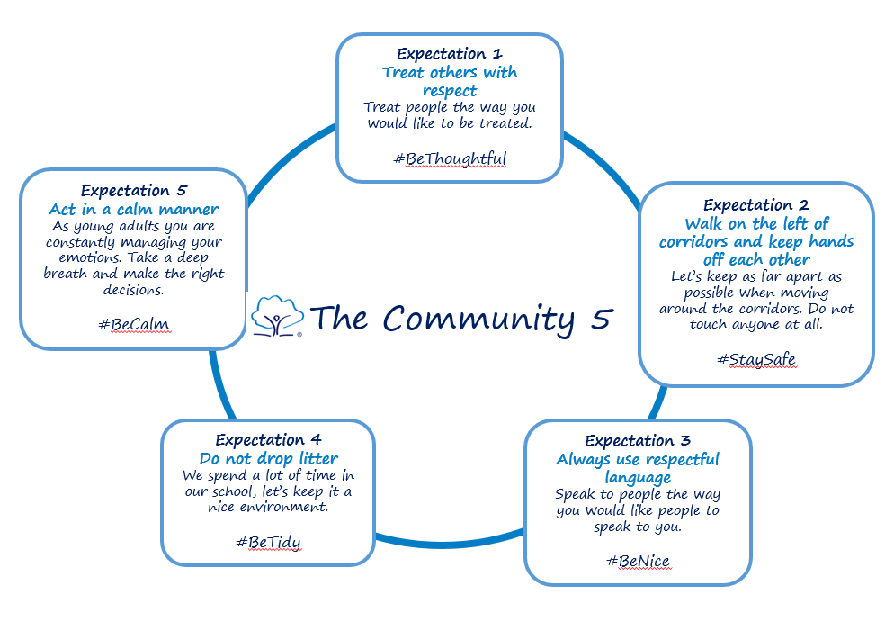

Mobile Phones
Mobile phones must remain out of sight and switched off between 8.15am and 3.30pm. This includes break and lunchtimes. Phones must not be seen or heard. On the school site, we are a no phones school. Linked devices such as earphones, air pods, or smart watches are also not permitted.

If a mobile phone is seen or heard, it will be treated as causing disruption to learning, and the mobile phone sanctions will be applied, and parents will be notified by text message:

• 1st offence: phone confiscated until end of the day; stored in a locked cabinet and then collected from the headteachers office, by the student.
• 2nd and any further offences: phone confiscated until end of day, stored in a locked cabinet and a parent/carer, or another adult nominated by the parent/carer, must collect from reception.
• 3rd offence: as above plus half a day in Student Support Unit – remove room.
• 4th offence: as above plus a day in Student Support Unit – reflection room.

Any subsequent offences further sanctions will apply. Refusal to hand over the mobile phone is a high tariff behaviour and will result in the young person being directed to the student support unit – reflection room. If the pupil continues to show defiance, they will either be directed to another school for a period of time or suspended in line with the school’s behaviour policy.

We recognise that mobile phones may have a part to play in securing students’ personal safety before and after school, and on journeys to and from school. If you feel that your child needs to bring their mobile phone to school, can you please make sure you have read the policy and go through the policy with your child particularly the section regarding sanctions if they use their mobile phone during the day. Please note that the school accepts no responsibility for any loss or damage to a mobile phone whilst the device is on the school premises. The academy will follow statutory guidance issued by the Department for Education when deciding what to do with a seized prohibited item.

We appreciate that there are sometimes life events or situations where a student may feel they need contact with home during the day. Please encourage your child to speak to their Pastoral Head of Year if they should ever feel like this as they are best placed to support them in school.

We also ask parents/ carers not to contact your child during the school day through calls, texts or social media as sanctions are applied to students who do not follow the policy when responding to communications from parents/carers. If parents/carers need to contact their children as a matter of urgency, they should always contact the school via the main reception 0114 239 2631.

Bullying
Bullying is defined as the repetitive, intentional harming of one person or group by another person or group, where the relationship involves an imbalance of power. Bullying is, therefore:
- Deliberately hurtful
- Repeated, often over a period of time
- Difficult to defend against
Bullying will not be tolerated at the academy. We have a ‘TELLING’ ethos where every allegation of bullying will be investigated. We do not accept name calling or inappropriate language as ‘banter’.

Please see our Peer Conflict and Anti-bullying Policy for full details.

Lateness policy:

If a pupil is late to school the following will take place:
- Arrives during form time, the pupil will remain with the supervised until the start of period 1 when they will be released to lesson. They will serve a 20-minute detention at the end of the day.
- Arrives during period 1, the pupil will be escorted to the remove room and will remain in the remove room until the start of period 2, when they will be released to period 2 lesson. They will serve a 50-minute detention at the end of the day.
- Arrives during period 2 onwards, the pupil will be escorted to the reflection room and remain in the reflection room until 4pm.

Please note, if a pupil arrives late to the academy and a parent/ carer has made contact with school to give an explanation then the pupil will be released to the next lesson at the next possible opportunity and no detention served.

Late is defined as arriving after the second bell has gone.
Detentions:

Detentions take place in the student support unit and are supervised by a member of the behaviour for learning team and a Head of Year.
Any pupil who disrupts detention or who fails to complete the detention will be issued with a ‘High Tariff’ for the next day (or an appropriate ‘Sanction’ to be levied after a discussion has taken place between the head of behaviour and SLT.)

The Academy is not obliged to give parents 24 hours’ notice of a detention and parental permission to detain a child is not required. A text message will be sent to inform parents of their child being levied with a high tariff behaviour, which will include a notification of a 50-minute detention at the end of the school day.

It is the responsibility of all parents to ensure that the academy has up to date contact numbers recorded on their child’s Arbor record. This is vital not only for the purposes of communicating about behaviour but for other circumstances such as in medical emergencies, weather related closure etc. as well.

In giving detentions, the academy will ensure that the impact of the detention on the pupil’s travel arrangements is reasonable. We recognise that a small number of pupils travel from out of catchment and that this may pose them difficulties. The welfare of the child will be considered along with factors such as any caring responsibilities held by the child.

By law, the permitted times for detentions are:
- any school day when the pupil does not have permission to be absent
- weekends but not those at the beginning and end of half term holidays
- teacher training days

The academy reserves the right to impose a detention on a pupil outside school sessions which may include ‘after school’ on a normal school day, a Saturday or Sunday during school term or a training day.

Academy Service
In order to repair the damage to the academy community that the behaviour of a pupil has caused, a pupil may be required to perform Academy Service. This may include service in the canteen, helping tidy up at the end of the academy day or removing graffiti or litter from the academy grounds.
Parents may be charged for the cost of any damage caused by a pupil if their behaviour has been found to have been malicious e.g., damage caused to a ‘mag-locked’ door by kicking it open, broken windows, removal of graffiti etc.

Reports:
Pupils can be placed on report to monitor their conduct, progress and application to their studies. Reports can be issued at Head of Year, CAL or SLT Level.
- Head of Year – A pattern of inappropriate behaviour, lack of engagement or poor progress within a specific curriculum area
- Curriculum area leader - lack of engagement or poor progress within a specific curriculum area identified through the academy’s Steps progress tracking system or repeated ‘Sanction 2’s within the curriculum area.
- Senior Leadership Team (Assistant Principal) – if pupil has failed HOY Report, or behaviour is deemed a concern which warrants daily SLT monitoring.

Drugs
The academy operates a zero-tolerance policy on drugs for the health and safety of all staff, pupils, and visitors. The Academy policy on drugs applies to all school and school related activities whether on or off site. This includes the journey to and from the academy. The word ‘drugs’ used in this policy does not just mean illegal drugs. It extends to alcohol, tobacco products, volatile substances, legal highs and ‘over the counter’ / prescription medicines which are being misused or are in a pupil’s possession inappropriately.

The Academy takes into account guidance issued by the DfE. The academy will monitor and deal with any drugs issues promptly and be proactive in trying to prevent any future drugs incidents. Pupils will receive drugs education as part of the PSHE programme and the academy will also involve outside agencies such as drugs education charities. It is the clear expectation of the academy that parents will support a Community Youth Team referral in such circumstances. Any incidents will be reported to the governors for their consideration and to South Yorkshire Police and local authority multi-service agencies (where appropriate).

Any pupil found to be involved in a drugs related incident will be disciplined in accordance with the academy’s behaviour policy. The sanction may include a suspension or permanent exclusion from school in the case of more serious offences, particularly those which involve the dealing of / distribution of illegal drugs. Using illegal drugs will, except in exceptional circumstances lead to exclusion, which may be permanent.

Confiscation of drugs
Any drugs found will be confiscated by staff from the academy’s Senior Leadership Team (or an appropriate member of staff to whom this duty has been delegated) who will dispose of them in accordance with guidance issued by the DfE.

Similarly, any drugs related paraphernalia such as needles will be disposed of in a prudent manner.

The academy may carry out searches for drugs in accordance with the school behaviour policy.

Parental involvement
Usually, the academy will inform parents/carers when their child has been found to be involved in drugs but where there are potential child protection issues the academy must act in the best interests of the child which may mean a decision not to inform parents. Such a decision will be taken very seriously and usually with the benefit of advice from partner agencies such as Social Care / South Yorkshire Police and / or having sought legal advice.”

Reasonable Force
Reasonable force can be applied by a member of staff on the premises or off the premises if the pupil is under control of that member of staff. It can also be applied by a person who the Headteacher has temporarily put in charge of pupils such as unpaid volunteers or parents accompanying pupils on a school organised visit.

The term ‘reasonable force’ covers the broad range of actions used by most teachers at some point in their career that involve a degree of physical contact with pupils.

Force is usually used either to control or restrain. This can range from guiding a pupil to safety by the arm through to more extreme circumstances such as breaking up a fight or where a pupil needs to be restrained to prevent violence or injury.

- ‘Reasonable in the circumstances’ means using no more force than is needed.

Teachers at the academy will generally use reasonable force to control pupils and to restrain them. Control means either passive physical contact, such as standing between pupils or blocking a pupil's path, or active physical contact such as leading a pupil by the arm out of a classroom.

- Restraint means to hold back physically or to bring a pupil under control. It is typically used in more extreme circumstances, for example when two pupils are fighting and refuse to separate without physical intervention.

Academy staff should always try to avoid acting in a way that might cause injury, but in extreme cases it may not always be possible to avoid injuring the pupil.

Staff at the academy are permitted by law to use reasonable force to:

- Remove disruptive children from the classroom where they have refused to follow an instruction to do so.
- Prevent a pupil behaving in a way that disrupts a school event or a school trip or visit.
- Prevent a pupil leaving the classroom where allowing the pupil to leave would risk their safety or lead to behaviour that disrupts the behaviour of others.
- Prevent a pupil from attacking a member of staff or another pupil, or to stop a fight in the playground.
- Restrain a pupil at risk of harming themselves through physical outbursts.

They cannot:

- Use force as a punishment – it is always unlawful to use force as a punishment.

The decision on whether or not to physically intervene is down to the professional judgment of the staff member concerned and should always depend on the individual circumstances.

Reasonable force can be applied to prevent a pupil:

- Committing an offence.
- Causing personal injury to any person, including himself or herself.
- Causing damage to property.
- Prejudicing maintenance of good order either during a lesson or otherwise

Powers to Search and Confiscation of Prohibited Items

Powers to Search

Academy staff can search a pupil for any item if the pupil agrees to this.

The Headteacher and staff authorised by him have a statutory power to search pupils or their possessions, without their consent, where they have reasonable grounds to suspect that the pupil may have a prohibited item.

Prohibited items (the possession of which will be subject to sanctions outlined in the table on page 6) are:
- Knives or other weapons
- Alcohol
- Illegal drugs
- Prescription drugs which have not been issued to that pupil and which they should not be in possession of
- Over the counter medicines which, on balance of probability, it is inappropriate for the pupil to be in possession of
- ‘Legal’ highs such as those containing methoxamine, synthetic cannabinoids and 5 and 6 APB (but not exclusively restricted to these)
- Stolen items
- Tobacco, smoking paraphernalia and E-Cigarettes
- ‘Energy Drinks’ such as those containing caffeine, taurine or other, similar ingredients.
- Fireworks
- Pornographic materials, whether printed or stored electronically
- Mobile phones, MP3 players and other consumer electronic devices (with the exception of tablets / laptops provided by the academy to pupils in order to support specific aspects of their learning)
- Any other article which a member of staff reasonably suspects has been, or is likely to be used to:
  - Commit an offence.
  - Cause personal injury to any person, including himself or herself.
  - Cause damage to property.
  - Prejudice the maintenance of good order either during a lesson or otherwise

The search may be carried out on the school premises or where the member of staff has lawful control of the pupil. The search may only be carried out by the Headteacher / Deputy Headteacher/ Assistant Headteacher or by a member of staff who has been authorised by the Headteacher / Deputy Headteacher/ Assistant Headteacher to carry out the search.

The person carrying out the search
- May not require the pupil to remove clothing other than outer clothing.
- Must be of the same sex as the pupil.
- Must be carried out in the presence of another member of staff also of the same sex as the pupil.
- The pupil’s possessions may only be searched in the presence of the pupil himself and another member of staff.

It is a condition of having a locker in the academy that the pupil gives their consent to it being searched.

Any formal complaints about being searched should be made in accordance with the academy’s usual complaint’s policy.

Confiscation of Items
Confiscation is lawful as a disciplinary penalty. The academy reserves the right to confiscate any item of pupils’ property which has been, or it is suspected might be used to:
- Commit an offence.
- Cause personal injury to any person, including himself or herself.
- Cause damage to property.
- Prejudice the maintenance of good order either during a lesson or otherwise

Confiscation may be for any period or the property may be disposed of.

Monitoring and Review

At Sheffield Springs Academy we monitor behavioural issues and to evaluate the effectiveness of the behaviour policy. This helps to ensure that we consider whether there are patterns of concerning, problematic or inappropriate behaviour among pupils which may indicate that there are possible cultural issues within the school which may be enabling inappropriate behaviour to occur. When patterns are identified, the school will decide on an appropriate course of action, which may include more staff training, re-inducting students through PSHE lessons, assemblies or amending the policy.

